**Creating CloudWatch monitoring dashboard**

Navigate to CloudWatch 🡪 Dashboard and click on create dashboard

Provide the name of the dashboard and create dashboard.

Once the dashboard is created click on the plus sign on right side to add the widgets



Select the Data type as Metrics and Widget type as line:

In the Add Metric graph select EC2

Select Per-Instance Metrics

Search instance id to collect the metrics

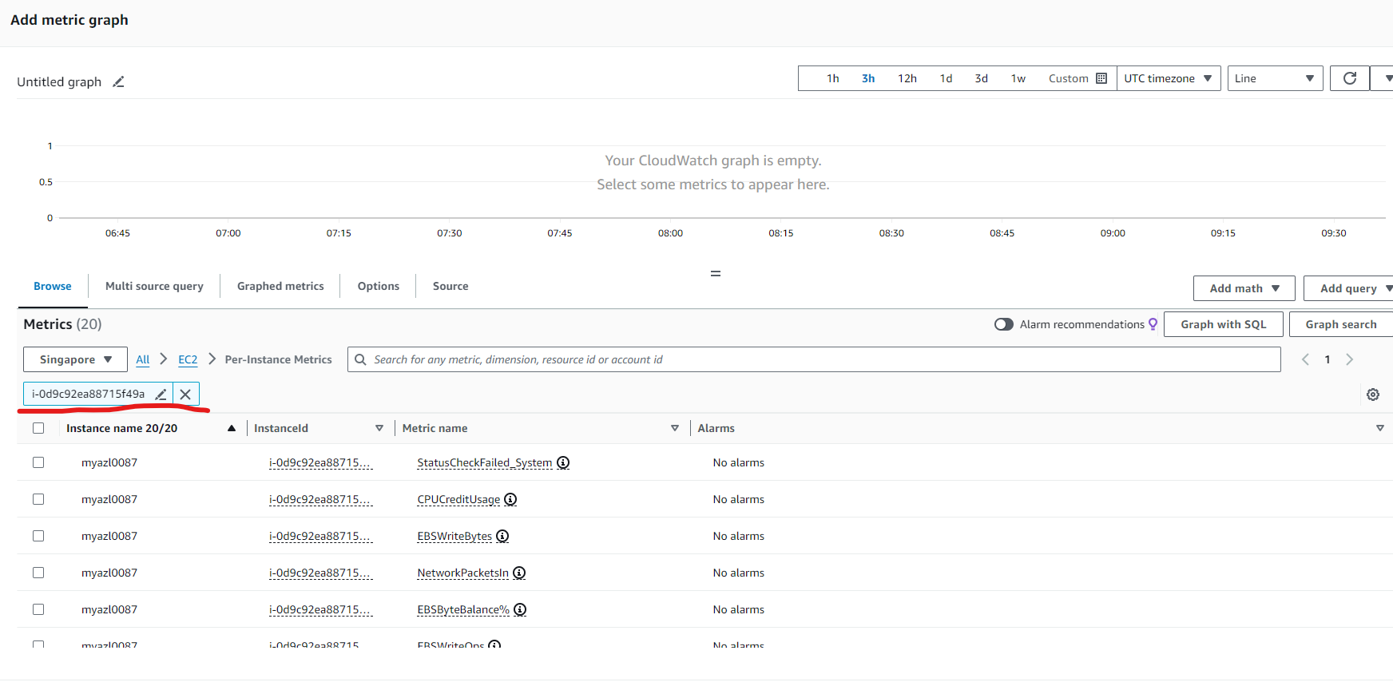

And select any metrics for example CPUUtilization

Select CPUUtilization and give Graph name as below:

Create Widget

Repeat the task for other required metrics.